**MGT 388 Finance and Law for Engineers**

**Finance Lecture 1 Notes**

What is accounting?

Accounting is concerned with collecting, analysing, and communicating financial information.

“The process of identifying, measuring and communicating economic information to permit informed judgements and decisions by users of the information.” Examples of decisions:

1. Formulating organisational strategies and long-range plans
2. Resource allocation decisions- e.g., product and customer emphasis and pricing

1. Cost planning and cost control of operations and activities
2. Performance measurement and evaluation of people 5. Meeting external regulatory and legal reporting requirements

(Horngren, 2005).

How a working knowledge of accounting can help you in the future.

Accounting is a central part of a business information system. Decisions on plans, projects, investments, fund raising and hiring of employees are not made without reference to the financial implications.

This is not only the case for a business with a profit-making objective, but also non-profit organisations, research and development centres will not be awarded funding unless there is evidence of a return or the potential for a return.

# Some examples from real cases

## Institute of Engineering and Technology

*“To be successful in a competitive market you must combine your technical abilities with sound commercial judgement”.*

## National Career Service

*“Typical aspects of an engineer’s role will include assessing if projects are feasible, planning the requirements of a project, preparing bids for tender, overseeing a processing plant and managing a team”.*

## Civil Engineering

*“You may be responsible for projects and teams, so you will need to make sure you estimate your expenditure accurately and then seek to control those costs”.*

## Chemical Engineering

*“Careers in the energy, waste food and pharmaceutical sectors are commonplace. You may be involved in researching a new product how will you decide if the benefit outweighs any costs. Which costs are relevant? How do you determine the financial benefit accruing at a future date? How do you determine whether to carry on? A project will need to be technically and commercially feasible”.*

## Materials engineer (YouTube)

*“You may be required to develop some adhesive material to use in commercial projects and to decide whether to continue to full scale production”.*

## IT

*“Will a project be profitable? If you are in business on your own account, how do you determine the price for the service you provide? How do you assess the credit worthiness of customers? Where should you obtain funding from?”*

## Beverley Gibbs

*“When I was a 23-year-old Production Engineer in polymer processing, I was asked to both identify and perform process improvement projects. I realised that by adding a crystallising agent to a polypropylene line I could speed up the cycle time. I designed a trial did the processing and compliance testing. This was successful so I calculated the extra costs for the material and the machine time that would be saved. This calculation produced a profit of £250,000 per year. However, the project was not taken on this is because the extra cost of materials led to cash outflow, but the machine time saved could not bring any extra revenue, and as it was a fixed cost did not reduce costs. Therefore, from a business perspective it was not commercially feasible”.*

# Financial Accounting

The field of accounting deals with the preparation of financial statements that are to be used by users external to an organisation.

The objective of financial statements is “*to provide information about the financial position, performance and changes in financial position of an entity that is useful to a wide range of users in making economic decision*” (International Accounting Standard Board - IASB Framework).

Financial position- wealth/worth (assets/liabilities/equity) 财务状况 - 财富/价值（资产/负债/权益）

Financial performance – profit/loss (revenues/expenses) 财务业绩 – 利润/亏损（收入/支出）

(e.g., for a bank account the financial position would be the funds held in the account at a point in time; the financial performance of the bank account is the interest/profit that it has earned).

Economic decisions – to invest in the company, to work for the company, to supply the company with goods, to loan funds to the company.

**Annual Report** = Accounts = Financial statements 年度报告 = 账户 = 财务报表

This refers to the annual financial information that is published by a company under regulations and which is subject to an audit. The Annual Reports of major companies now also contain a lot of narrative information only some of which is regulated.

The information in the annual reports can be used as a marketing tool by the company to attract customers, suppliers of finance, good press as well as investors. They will highlight a company’s objectives which may be profit focused, but as the importance of corporate social responsibility has become more widely recognised there will be other objectives.

The annual report contains financial statements together with notes explaining them:

1. The income statement (also referred to as ‘statement of profit or loss’ or ‘profit and loss account’)
2. The statement of financial position (also referred to as ‘balance sheet’)
3. The statement of cash flow (also referred to as ‘cash flow statement’).

损益表（也称为“损益表”或“损益表”）

财务状况表（也称为“资产负债表”）

现金流量表（也称为“现金流量表”）。

# Income Statement

## Income Statement = Profit and Loss Account

The income statement details the profit that a company has made over the year. It provides information on the financial performance of the company.

损益表详细列出了公司一年来的利润。 它提供有关公司财务业绩的信息。

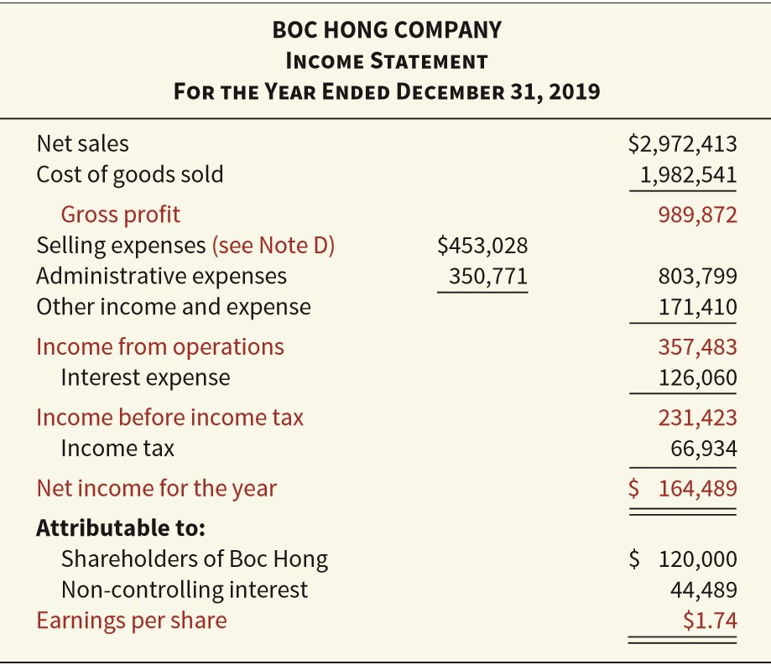

## Revenue = Turnover = Sales 收入 = 营业额 = 销售额

This caption should only include income from the main business (lines of operation) that the company is involved in. Income from other investments or one-off sources should be included elsewhere.

此标题应仅包括公司参与的主营业务（经营范围）的收入。其他投资或一次性来源的收入应包括在其他地方。

## Cost of sales 销售成本

This caption includes all the expenses/costs that are involved in manufacturing and producing the product that the company sells.

包括制造和生产公司销售的产品所涉及的所有费用/成本。

It includes:

Opening inventory X 初期库存

Add Purchases X 增加购买项目

Less Closing inventory (X) 减去期末库存

Add production costs X 增加生产成本

Cost of sales X 销售成本

## Gross Profit 毛利

As revenue and cost of sales do not contain any one-off items, gross profit is a basic guide of how successful the core business of a company is. It compares the revenue from selling the product a company produces directly with the costs of that production.

由于收入和销售成本不包含任何一次性项目，毛利是公司核心业务成功与否的基本指南。它将销售公司直接生产的产品的收入与生产成本进行比较。

## Selling Expenses 销售费用

This caption includes all the selling, marketing and distribution costs incurred by a company.

此标题包括公司产生的所有销售、营销和分销成本。

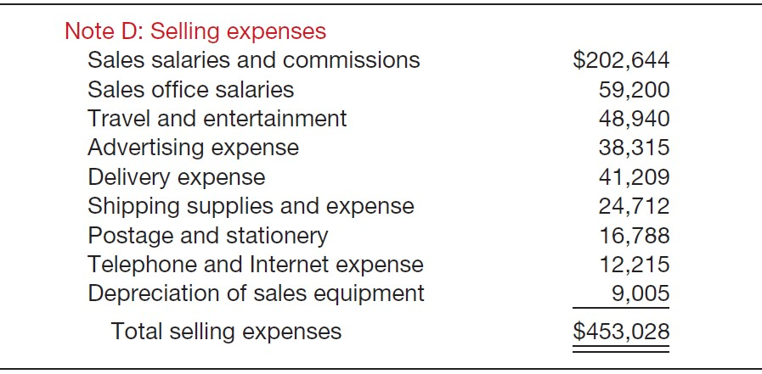

## Administration Expenses 行政开支

This caption includes all the office-based costs of a company. These might include accountant and lawyer fees, debt collection services, invoicing and some director costs.

此标题包括公司的所有办公室成本。 这些可能包括会计师和律师费、收债服务、发票和一些董事费用。

## Operating Profit 盈利利润

This highlights the profit the business has generated from its operation. The figure is likely to be more volatile than the gross profit figure because one-off cost can be included in administration and selling expenses. A successful business will try and keep a tight control of the administration and selling costs. In a competitive marketplace this is very important.

这突出了企业从其运营中产生的利润。该数字可能比毛利润数字更不稳定，因为一次性成本可以包含在管理和销售费用中。一个成功的企业会尝试严格控制管理和销售成本。在竞争激烈的市场中，这一点非常重要。

## Finance Charges 财务费用

Payments of interest on loans, leases, and overdrafts. A business would be in trouble if the finance charges were more than the operating profit.

支付贷款、租赁和透支的利息。如果财务费用超过营业利润，企业将陷入困境。

# Statement of Financial Position

## Statement of financial position = Balance Sheet 财务状况表 = 资产负债表

This statement shows the worth of a company. It provides information on the financial position of the company.

这句话显示了一家公司的价值。它提供有关公司财务状况的信息。

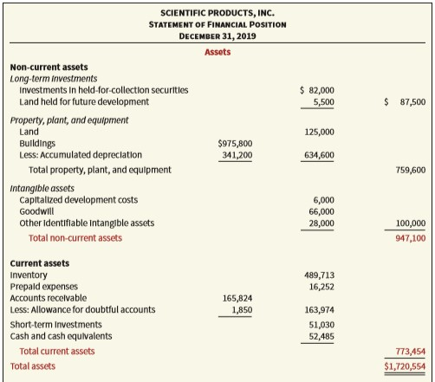

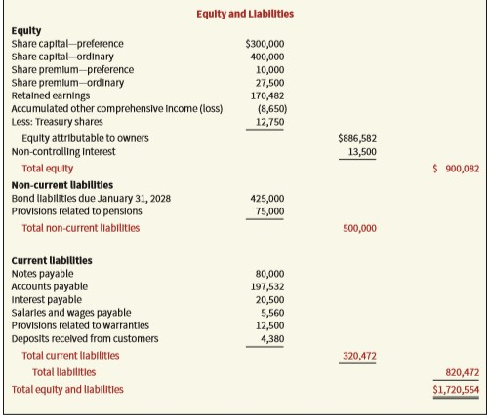

## Assets 资产

Assets are resources that are controlled by an entity that are expected to bring economic

benefits, (generate profits). Assets can be split into two categories:

Non-current assets – are to be owned for longer than 12 months (or the operating cycle*, whichever is longer).

Current assets – owned at the reporting date but are to be used by the business to make profits in the next 12 months (or the operating cycle*, whichever is longer).

*\*Glossary: An operating cycle refers to the time it takes a company to buy goods, sell them and receive cash from the sale of said goods.*

资产是由一个实体控制的资源，预计会带来经济利益

效益，（产生利润）。 资产可以分为两类：

非流动资产——拥有时间超过 12 个月（或营业周期*，以较长者为准）。

流动资产——在报告日拥有，但企业将在未来 12 个月（或营业周期*，以较长者为准）中使用它们来赚取利润。

*术语：营业周期是指公司购买商品、出售商品并从销售所述商品中获得现金所需的时间。

## Non-Current Assets = Fixed Assets 非流动资产=固定资产

* E.g., Buildings, furniture, machinery, and motor vehicles. These are tangible assets.
* E.g., Brands, patents, and goodwill. These are intangible assets.

## Current assets 流动资产

* Inventory=stock

These are the goods that the company intends to sell but has not yet sold. They are the items that the company manufactures/trades in and will comprise of finished goods, part finished goods known as work in progress, and raw materials. The three components raw materials, work in progress and finished goods are added together to provide an inventory figure.

* Trade receivables= Debtors

This is money that the company is owed from its customers at the reporting date.

* Prepayment - bills paid in advance.

## Liabilities 负债

A liability is an obligation of an entity arising from a past event the settlement of which

involves the transfer of resources (an amount owing by the business). Liabilities can be split into categories:

Non- Current – the payment of liability is due after 12 months (or the operating cycle*, whichever is longer).

Current – the payment of the liability is due within the next 12 months (or the operating cycle*, whichever is longer).

## 负债是实体因过去事件而产生的义务，该事件的解决涉及资源的转移（企业所欠的金额）。 负债可以分为几类：

## 非流动 – 债务支付应在 12 个月后（或营业周期*，以较长者为准）。

## 当前 – 负债的支付应在未来 12 个月内（或营业周期*，以较长者为准）。

## Non-Current Liabilities

• Bank loan repayable in 2/3/4…5 years, debentures, loan notes, sometimes preference shares.

## Current Liabilities

* Trade payables = creditors

Amounts the business owes to suppliers of raw materials etc.

* Accruals

Amounts the business owes in respect of bills not yet received, but where the business has used the service or products. Outstanding amounts owed on gas/electricity bills.

## Equity 权益

Equity represents “the residual interest in the assets of the entity after deducting all the liabilities”.

Equity belongs to the owners of the company who are the shareholders.

权益代表“扣除所有负债后实体资产的剩余权益”。

股权属于作为股东的公司所有者。

## Accounting Equation

ASSETS = LIABILITIES + EQUITY

The assets of a business equal the finance provided to the business by both third parties and the owners.

The accounting equation follows the separate entity concept, it looks at the financial position from the company perspective. What the company owns (assets) is set against what the company owes to the providers of finance (liabilities plus equity).

For the accounting equation to balance one transaction leads to two entries (Double Entry Concept). For example, a company buys a car for cash. The asset motor vehicles will

increase, and the asset cash will decrease by the same amount. If money is borrowed from a bank to buy a car, the asset car and the liability loans will both increase by the same amount.

企业的资产等于第三方和所有者向企业提供的资金。

会计等式遵循单独实体概念，从公司角度看待财务状况。 公司拥有的资产（资产）与公司欠融资提供者的债务（负债加股本）相对应。

对于平衡一项交易的会计等式，会导致两项分录（复式分录概念）。 例如，一家公司用现金购买一辆汽车。 资产机动车辆将增加，资产现金将减少相同数量。 如果从银行借钱买车，资产车和负债贷款都会增加相同的金额。

Please have a look at this short video:

[The Accounting Equation for beginners](https://www.youtube.com/watch?v=56xscQ4viWE)

# Statement of Cash Flow

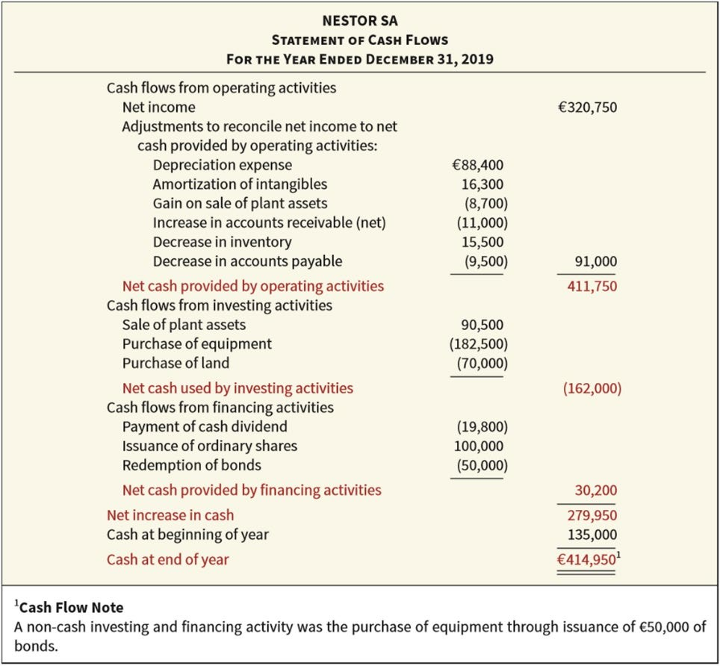

# Final note for students

The MGT388 students will not be expected to prepare a set of financial statements.

It is expected that you will understand the information that the various statements present to users and that you will be able to look at an Annual Report and make some judgements about the company.